

Name: Marcus Chong Vun Seng

Login ID: chongvunseng@oasis-portal.com

Course title: Accounting Fundamentals

Subject Code: BHM03

Submitted date:4/8/2017

**Table of Contents**

|  |  |  |
| --- | --- | --- |
| **No** | **Details** | **Page** |
| 1 | Executive Summary |  |
| 2 | Introduction |  |
| 3 | Assignment Question |  |
|  | What Is Accounting |  |
|  | Classification Of Account |  |
|  | Balance sheet |  |
|  | Reconciling an account |  |
| 4 | Conclusion |  |
| 5 | References |  |
|  | Appendix |  |

**Executive Summary**

In this assignment, I will explaining about what is accounting, bookkeeper is the recording of money related exchange in addition to solid , sorling , recovering ,and showing the data in different reports and analyses. Accounting is likewise a calling comprising of people having the formal instruction to complete these errands.One a player in bookkeeper forcuses on introducing the data as universally useful money related statements (balance sheet ,pay statement ,etc.) to individuals outside of the company. These outer reports must be set up as per sound accounting standards regularly alluded to as GAAP or US GAAP. This part of bookkeeper is alluded to as budgetary bookkeeper. Bookkeeper additionally involves giving an organization administration the data it needs to keep the business monetarily solid. These examinations and reports are not appropriated outside of the organization. A portion of the data will begin from the recorded exchanges however a portion of the data will be evaluations and projections in light of different suspicions. Three cases of inward investigations and reports are budget, standards for controlling operations, and evaluating offering costs for citing new occupations. This region of bookkeeping is known as administration bookkeeper. Another piece of bookkeeper includes consistence with government directions relating to pay impose announcing. Today a significant part of the recording , storing ,and arranging parts of bookkeeper have been mechanized as consequence of the advances in PC innovation.

**CLASSIFICATION OF ACCOUNT**

It is necessary to know the classification of accounts and their treatment in double entry system of accounts. Broadly, the accounts are classified into three categories:

* Personal accounts
* Real accounts
  + Tangible accounts
  + Intangible accounts

Let us go through them each of them one by one.

Personal Accounts

Personal accounts may be further classified into three categories:

Natural Personal Account

An account related to any individual like David, George, Ram, or Shyam is called as a *Natural Personal Account*.

Artificial Personal Account

An account related to any artificial person like M/s ABC Ltd, M/s General Trading, M/s Reliance Industries, etc., is called as an *Artificial personal account*.

Representative Personal Account

Representative personal account represents a group of account. If there are a number of accounts of similar nature, it is better to group them like salary payable account, rent payable account, insurance prepaid account, interest receivable account, capital account and drawing account, etc.

Real Accounts

Every Business has some assets and every asset has an account. Thus, asset account is called a real account. There are two type of assets:

* **Tangible** assets are touchable assets such as plant, machinery, furniture, stock, cash, etc.
* **Intangible** assets are non-touchable assets such as goodwill, patent, copyrights, etc.

Accounting treatment for both type of assets is same.

Nominal Accounts

Since this account does not represent any tangible asset, it is called nominal or fictitious account. All kinds of expense account, loss account, gain account or income accounts come under the category of nominal account. For example, rent account, salary account, electricity expenses account, interest income account, etc.

**INTRODUCTION TO BALANCE SHEET**

The accounting balance sheet is one of the major financial statements used by accountants and business owners. The other major financial statements are the income statement, statement of cash flows, and statement of stockholders equity. The balance sheet is also referred to as the statement of financial position. The monetary record introduces an organization money related position toward the finish of a predetermined date.some depict the accounting report as a preview of the organization budgetary position at a point(a minute or a moment) in time. For example, the sums wrote about an asset report dated December 31,2016 mirror that moment when all the exchange through December 31 have been recorded. Since the accounting report educates the peruser of an organization monetary position starting at one minute in time, it permits somebody like a loan boss to perceive what an organization claims and in addition what it owes to different gatherings as of the date demonstrated in the heading. This is important data to the financier who needs to decide if an organization meets all requirements for extra credit or advances. Other people who might be occupied with the accounting report incorporate current investors, potential investors, company management, suppliers, some customers, competitors , government agencies, and work unnions. To some degree one we will clarify the segments of the asset report and to some extent two we will show a specimen accounting report. On the off chance that you are keen on asset report examination, that is incorporated into the clarification of money related proportions.

We will start our clarification of the bookkeeper asset report with its significant parts, elements, or real classifications:

* **ASSETS**
* **LIABILITIES**
* **OWNER’S**

In bookkeeper mentor master you will locate some uncommon materials on the adjust sheet. For example ,the video class understanding budgetary articulation gives a line by line clarification of an accounting report. Ace likewise incorporates a visual instructional exercise, business forms, and exam addresses that will enable you to learn and hold data on the monetary record.

**ASSETS**

Assets are things that the company owns. They are the resources of the company that have been acquired through transactions, and have future economic value that can be measured and expressed in dollars. Assets also include costs paid in advance that have not yet expired, such as prepaid advertising, prepaid insurance, prepaid legal fees, and prepaid rent. For a discussion of prepaid expenses go to explanation of adjusting entries.

Example of asset accounts that are reported on a company’s balance sheet includes:

* **CASH**
* **PETTY CASH**
* **TEMPORARY INVESTMENTS**
* **ACCOUNTS RECEIVABLE**
* **INVENTORY**
* **SUPPLIES**
* **PREPAID INSURANCE**
* **LAND**
* **LAND IMPROVEMENTS**
* **BUILDINGS**
* **EQUITMENT**
* **GOODWILL**

Usually asset accounts will have debit balances.

Contra assets are asset accounts with credit balances. A credit balance in an asset account is contrary or contra to an asset account’s usual debit balance. Example of contra asset account include:

* Allowance for doubtful accounts
* Accumulated depreciation land improvements
* Accumulated depreciation buildings
* Accumulated depreciation equipment
* Accumulated depletion

Accountants usually prepare classified balances sheets.

* Current Assets
* Investments
* Property
* Intangible Assets
* Other Assets

A blueprint of a monetary record utilizing the accounting report arrangement is appeared here:

|  |  |
| --- | --- |
| **ASSETS** | **LIABILITIES** |
| Current assets | Current liabilities |
| Investments | Long-term liabilities |
| Property | Total liabilities |
| Intangible assets | Owner equity |
| Bank | Trade payable |
| Debtor | Capitals |

**RECONSILING AN ACCOUNT**

**Define of Bank Reconciling Statement.**

Bank Reconciling Statement is a statement arranged on a specific day to reconcile the bank balance according to cash book with the balance according to bank pass book, showing passages causing distinctive between the two balances. In other words, it is a procedure that clarifies the distinction between the bank balances appeared in an association’s bank statement, as provide by the bank, and the corresponding amount appeared in the association’s own cash book on a particular point of time.

**The purpose and importance the bank reconciling Statement.**

Every company use bank reconciling statement is to compare the company’s business records to those of company bank, to check whether there has distinctive between records of cash transactions. The importance using bank reconciling statement is to **identify errors**. Bank reconciliations help to distinguish mistakes that can come about because of cheques that are inaccurately posted to an organization’s bank account. For instance, if an organization deposits a cheque in the total amount of $46,000, yet the bank erroneously credits the bank account for $4,600, reconciliation of the deposits appeared on the organization’s bank statement with the balance appeared on its books may distinguish the error.

In addition, the importance using bank reconciling statement is maintaining accurate records. An organization’s cash balance is shown on its balance sheet inside the current asset section and is the organization’s most liquid asset. Since an organization’s cash balance is incorporated out many key productivity and liquidity ratios that assess an organization’s execution and money related circumstance, the balance ought to be reconciled month to month to guarantee that it is both accurate and reliable.

**The differences cash book and bank statement**

The definition of **cash book is cash book balance will show the cash balance recorded by the company in company’s cash book**. The transaction usually will include to cash book not in bank statement. First point is Deposits in transit .These are deposit sent by the organization to the bank however have not been gotten by the bank on time before issuing the bank statement. Second point is outstanding cheques. Outstanding cheques is allude to the cheques issued by the organization however were not exhibited or cleared before the issuance of the bank statement.

In addition, the definition of bank **statement is bank statement balance is the cash balance recorded by the bank in bank records. Administration Charges and interest income are records in bank statement not cash book. Administration Charges will be charges deducted by the bank. The organization will come to know about such charges just when they get the bank statement. In the event that, interest income has been earned by the organization on its bank account, it is not as a rule entered in organization’s cash account before the bank statement is issued.**

**The Format of Bank Reconciliation Statement.**

There have two ways to prepare Bank Reconciliation Statement. The first type format is taking bank balance as per cash book as the starting point. The second type format is taking bank balance as per pass book as the starting point.

Let’s see the first type format taking bank balance as per cash book as the starting point. The first thing should write in the bank reconciliation statement is Bank balance as per cash book. Then sum it up the items having the effect of higher balance in pass book. The next step is use the amount that found just now less or minus the items having the effect of lower balance in pass book. Last, will get the amount of bank balance as per pass book. In addition, I have prepared the format at below, can refer to appendix 1.

The second method is taking bank balance as per pass book as the starting point. It will have little similar with the first format. The first thing should write in the bank reconciliation statement is Bank balance as per pass book. Second step, sum it up the items having the effect of higher balance in cash book. The next step is use the amount that found just now less or minus the items having the effect of lower balance in cash book. Last, will get the amount of bank balance as per pass book. In addition, , I also have prepared this format at below, can refer to appendix 2.

**Appendix 1**

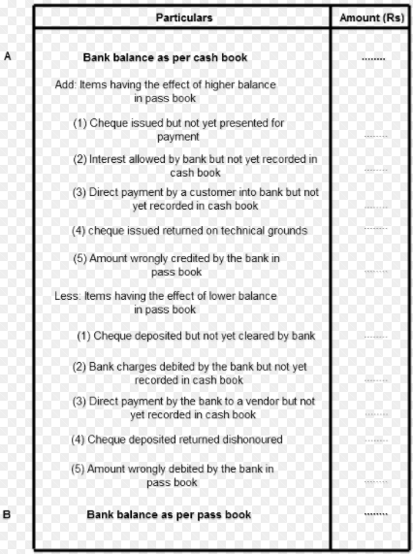

**Appendix 2**

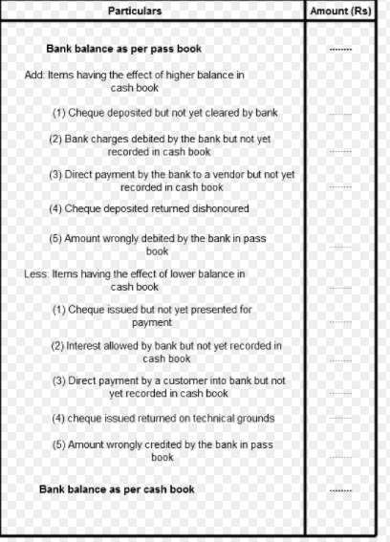

**CONCLUSION**

In this assignment I learn about what is accounting and balance sheet of bank.

**REFERENCES**

www.accountingcoach.com